已知立方和不等式为 13+ 23+…+ m3< n 对指定的n值，试求满足上述立方和不等式的m的整数解。

输入提示

同构数

625的右端，25就是同构

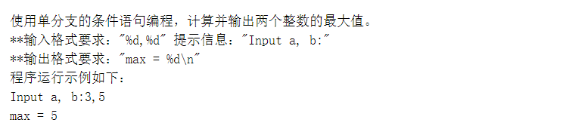

#include<stdio.h>

int main()

{

int a,b,max;

printf("Input a, b:");

scanf("%d,%d",&a,&b);

max = (a>b)?a:b;

printf("max = %d\n",max);

return 0;

}

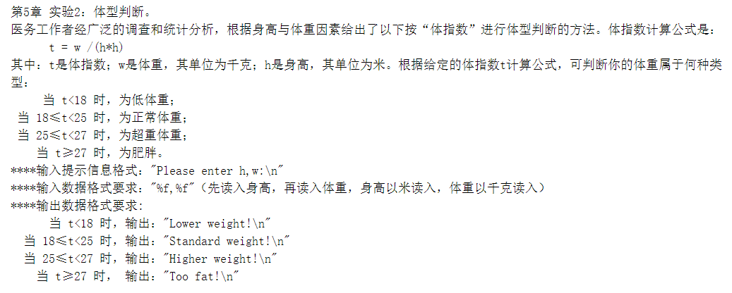

#include<stdio.h>

int main()

{

float h,w,t;

printf("Please enter h,w:\n");

scanf("%f,%f",&h,&w);

t = w/(h\*h);

if(t<18)

{

printf("Lower weight!\n");

}

else if(t>=18&&t<25)

{

printf("Standard weight!\n");

}

else if(t>=25&&t<27)

{

printf("Higher weight!\n");

}

else

{

printf("Too fat!\n");

}

return 0;

}

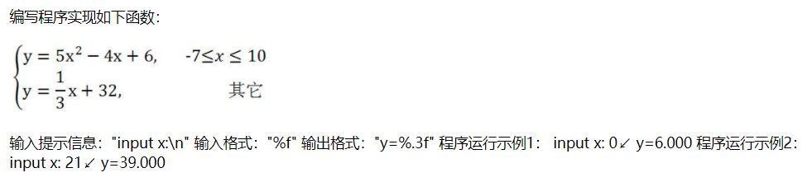

#include<stdio.h>

#include<math.h>

int main()

{

float x,y;

printf("input x:\n");

scanf("%f",&x);

if(x>=(-7)&&x<=10)

{

y = 5\*pow(x,2)-4\*x+6;

printf("y=%.3f",y);

}

else

{

y = x/3+32;

printf("y=%.3f",y);

}

return 0;

}

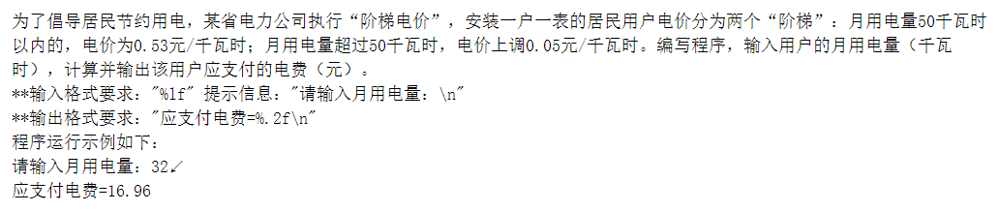

#include<stdio.h>

int main()

{

double a,b;

printf("请输入月用电量：\n");

scanf("%lf",&a);

if(a>=0&&a<=50)

{

b = 0.53\*a;

printf("应支付电费=%.2f\n",b);

}

else

{

b = (0.53+0.05)\*a;

printf("应支付电费=%.2f\n",b);

}

return 0;

}

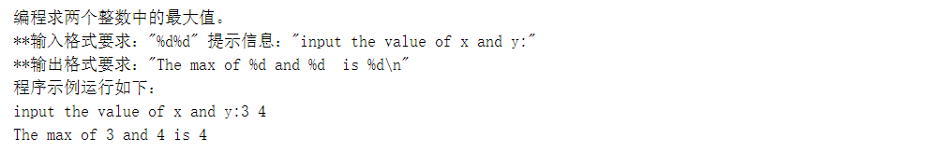

#include<stdio.h>

int main()

{

int x,y,max;

printf("input the value of x and y:");

scanf("%d%d",&x,&y);

max = (x>y)?x:y;

printf("The max of %d and %d is %d\n",x,y,max);

return 0;

}

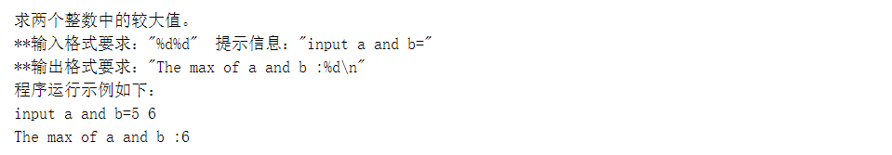

#include<stdio.h>

int main()

{

int a,b,max;

printf("input a and b=");

scanf("%d%d",&a,&b);

max = (a>b)?a:b;

printf("The max of a and b :%d\n",max);

return 0;

}

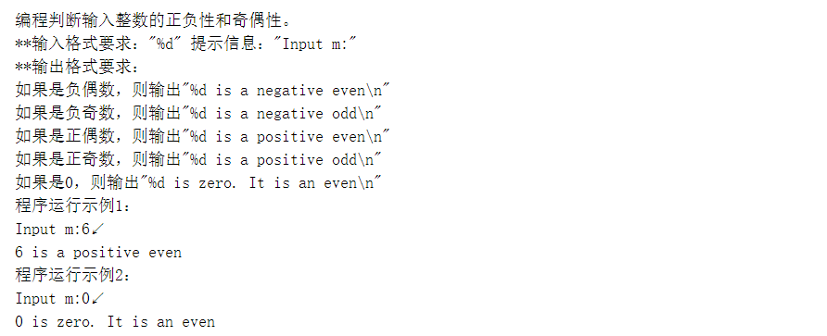

#include<stdio.h>

int main()

{

int a,b;

printf("Input m:");

scanf("%d",&a);

if(a==0)

{

printf("%d is zero. It is an even\n",a);

}

else if(a>0)

{

b = a%2;

if(b==0)

{

printf("%d is a positive even\n",a);

}

else

{

printf("%d is a positive odd\n",a);

}

}

else

{

b = a%2;

if(b==0)

{

printf("%d is a negative even\n",a);

}

else

{

printf("%d is a negative odd\n",a);

}

}

return 0;

}

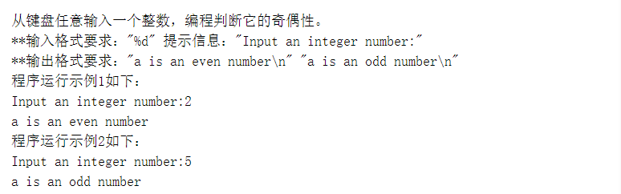

#include<stdio.h>

int main()

{

int a,b;

printf("Input an integer number:");

scanf("%d",&a);

b = a%2;

if(b==0)

{

printf("a is an even number\n");

}

else

{

printf("a is an odd number\n");

}

return 0;

}

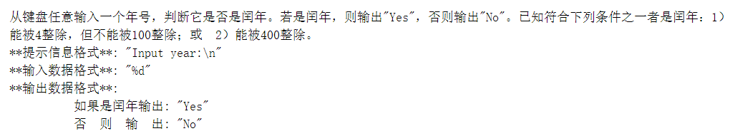

#include<stdio.h>

int main()

{

int a,b,c,d;

printf("Input year:\n");

scanf("%d",&a);

b = a%4;

c = a%100;

d = a%400;

if((b==0&&c>0)||d==0)

{

printf("Yes");

}

else

{

printf("No");

}

return 0;

}

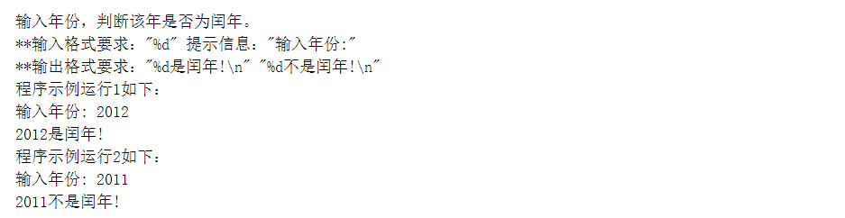

#include<stdio.h>

int main()

{

int a,b,c,d;

printf("输入年份:");

scanf("%d",&a);

b = a%4;

c = a%100;

d = a%400;

if((b==0&&c>0)||d==0)

{

printf("%d是闰年!\n",a);

}

else

{

printf("%d不是闰年!\n",a);

}

return 0;

}

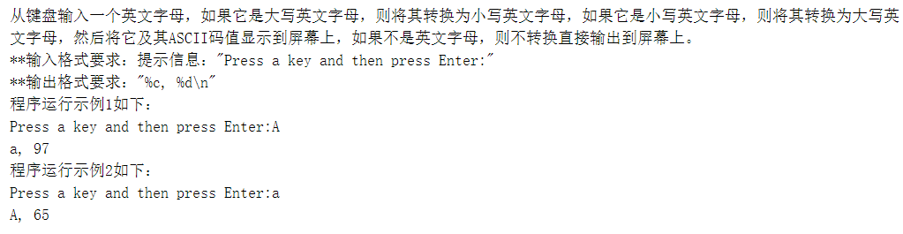

#include<stdio.h>

int main()

{

char ch;

printf("Press a key and then press Enter:");

ch = getchar();

if(ch>='A'&&ch<='Z')

{

ch = ch + 32;

printf("%c, %d\n",ch,ch);

}

else if(ch>='a'&&ch<='z')

{

ch = ch - 32;

printf("%c, %d\n",ch,ch);

}

return 0;

}

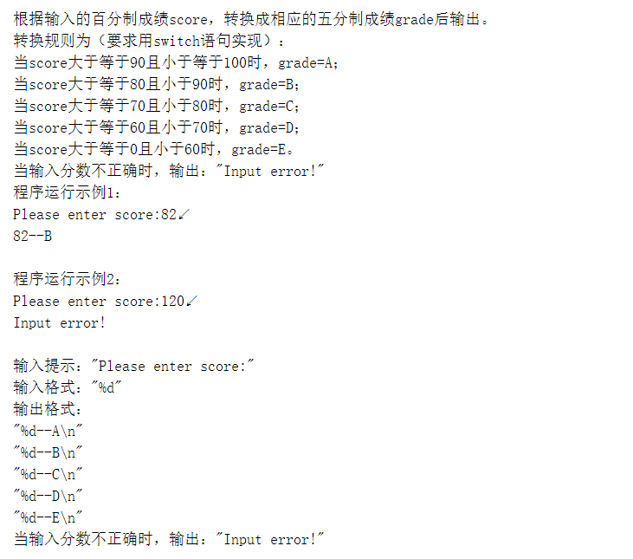

#include<stdio.h>

int main()

{

int score;

printf("Please enter score:");

scanf("%d",&score);

if(score>=90&&score<=100)

{

printf("%d--A\n",score);

}

else if(score>=80&&score<90)

{

printf("%d--B\n",score);

}

else if(score>=70&&score<80)

{

printf("%d--C\n",score);

}

else if(score>=60&&score<70)

{

printf("%d--D\n",score);

}

else if(score>=0&&score<60)

{

printf("%d--E\n",score);

}

else

{

printf("Input error!");

}

return 0;

}

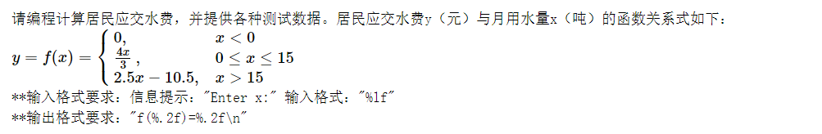

#include<stdio.h>

int main()

{

double x,y;

printf("Enter x:");

scanf("%lf",&x);

if(x<0)

{

y = 0;

printf("f(%.2f)=%.2f\n",x,y);

}

else if(x>=0&&x<=15)

{

y = (4\*x)/3;

printf("f(%.2f)=%.2f\n",x,y);

}

else if(x>15)

{

y = 2.5\*x-10.5;

printf("f(%.2f)=%.2f\n",x,y);

}

return 0;

}

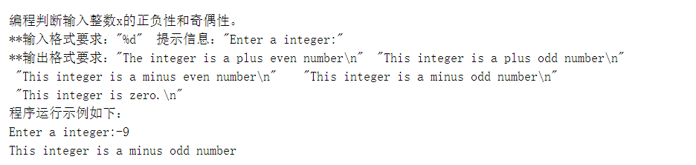

#include<stdio.h>

int main()

{

int a,b;

printf("Enter a integer:");

scanf("%d",&a);

b = a%2;

if(a==0)

{

printf("This integer is zero.\n");

}

else if(a>0)

{

if(b==0)

{

printf("The integer is a plus even number\n");

}

else printf("This integer is a plus odd number\n");

}

else

{

if(b==0)

{

printf("This integer is a minus even number\n");

}

else printf("This integer is a minus odd number\n");

}

return 0;

}

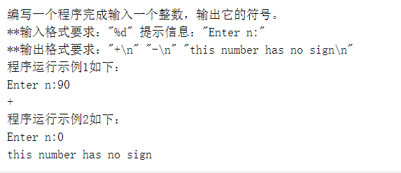

#include<stdio.h>

int main()

{

int n;

printf("Enter n:");

scanf("%d",&n);

if(n==0)

{

printf("this number has no sign\n");

}

else if(n>0)

{

printf("+\n");

}

else if(n<0)

{

printf("-\n");

}

return 0;

}

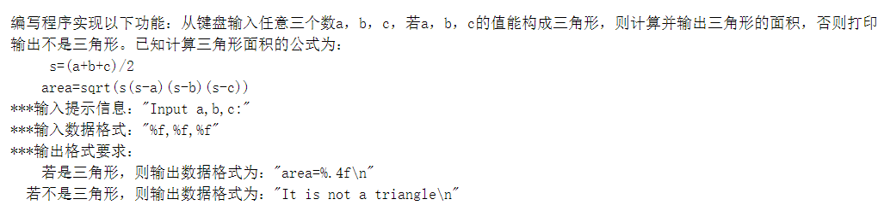

#include<stdio.h>

#include<math.h>

int main()

{

float a,b,c,s,area;

printf("Input a,b,c:");

scanf("%f,%f,%f",&a,&b,&c);

s = (a+b+c)/2;

area = sqrt(s\*(s-a)\*(s-b)\*(s-c));

if((a+b>c)&&(a+c>b)&&(b+c>a))

{

printf("area=%.4f\n",area);

}

else

{

printf("It is not a triangle\n");

}

return 0;

}

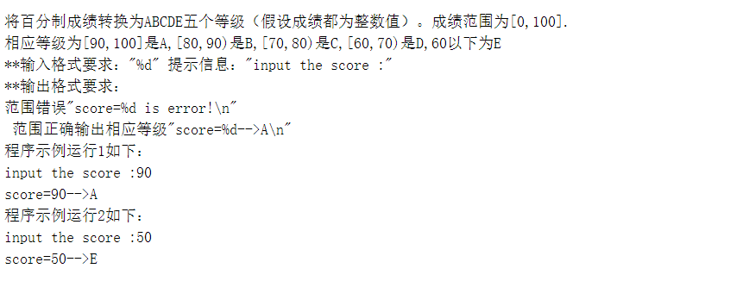

#include<stdio.h>

void main()

{

int a;

printf("input the score :");

scanf("%d",&a);

if (a>100||a<0) printf("score=%d is error!\n",a);

else if (a>=90) printf("score=%d-->A\n",a);

else if (a>=80) printf("score=%d-->B\n",a);

else if (a>=70) printf("score=%d-->C\n",a);

else if (a>=60) printf("score=%d-->D\n",a);

else printf("score=%d-->E\n",a);

return 0;

}

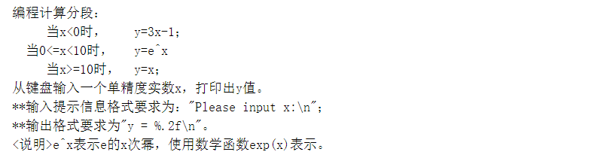

#include<stdio.h>

#include<math.h>

int main()

{

float x,y;

printf("Please input x:\n");

scanf("%f",&x);

if(x<0)

{

y = 3\*x-1;

}

else if(x>=10)

{

y = x;

}

else

{

y = exp(x);

}

printf("y = %.2f\n",y);

return 0;

}

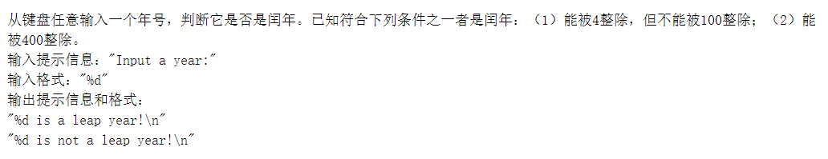

#include<stdio.h>

int main()

{

int a,b,c,d;

printf("Input a year:");

scanf("%d",&a);

b = a%4;

c = a%100;

d = a%400;

if((b==0&&c>0)||d==0)

{

printf("%d is a leap year!\n",a);

}

else printf("%d is not a leap year!\n",a);

return 0;

}

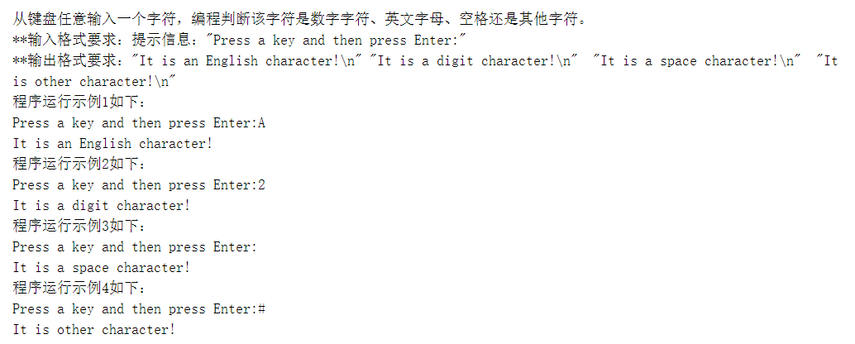

#include<stdio.h>

int main()

{

char a;

printf("Press a key and then press Enter:");

scanf("%c",&a);

if (a>64 && a<91||a>96 && a<123) printf("It is an English character!\n");

else if (a>47 && a<58) printf("It is a digit character!\n");

else if (a==32) printf("It is a space character!\n");

else printf("It is other character!\n");

return 0;

}

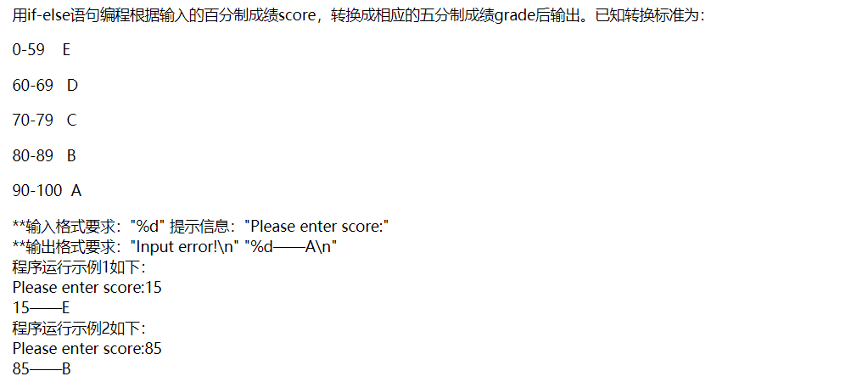

#include<stdio.h>

int main()

{

int a;

printf("Please enter score:");

scanf("%d",&a);

if(a>=0&&a<=59)

{

printf("%d——E\n",a);

}

else if(a>=60&&a<=69)

{

printf("%d——D\n",a);

}

else if(a>=70&&a<=79)

{

printf("%d——C\n",a);

}

else if(a>=80&&a<=89)

{

printf("%d——B\n",a);

}

else if(a>=90&&a<=100)

{

printf("%d——A\n",a);

}

else printf("Input error!\n");

return 0;

}

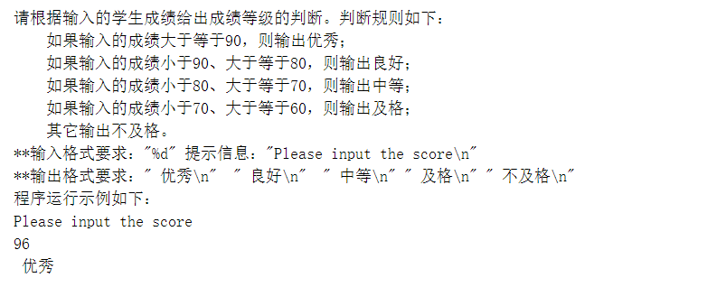

#include<stdio.h>

int main()

{

int a;

printf("Please input the score\n");

scanf("%d",&a);

if(a>=90)

{

printf(" 优秀\n");

}

else if(a>=80&&a<90)

{

printf(" 良好\n");

}

else if(a>=70&&a<80)

{

printf(" 中等\n");

}

else if(a>=60&&a<70)

{

printf(" 及格\n");

}

else

{

printf(" 不及格\n");

}

}

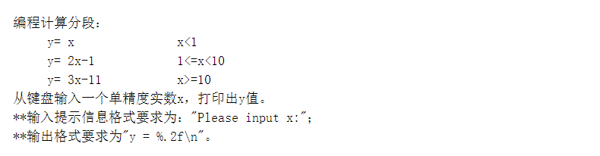

#include<stdio.h>

int main()

{

float x,y;

printf("Please input x:");

scanf("%f",&x);

if(x<1)

{

y = x;

}

else if(x>=10)

{

y = 3\*x-11;

}

else

{

y = 2\*x-1;

}

printf("y = %.2f\n",y);

return 0;

}

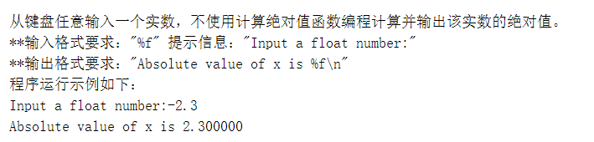

#include<stdio.h>

int main()

{

float n;

printf("Input a float number:");

scanf("%f",&n);

if(n<0)

{

printf("Absolute value of x is %f\n",(-n));

}

else

{

printf("Absolute value of x is %f\n",n);

}

return 0;

}

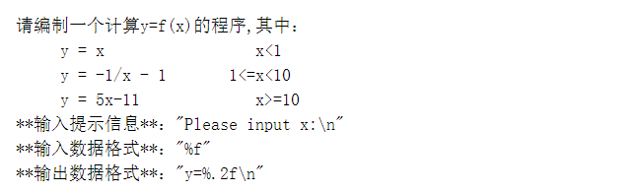

#include<stdio.h>

int main()

{

float x,y;

printf("Please input x:\n");

scanf("%f",&x);

if(x<1)

{

y = x;

}

else if(x>=10)

{

y = 5\*x - 11;

}

else

{

y = -1/x - 1;

}

printf("y=%.2f\n",y);

return 0;

}

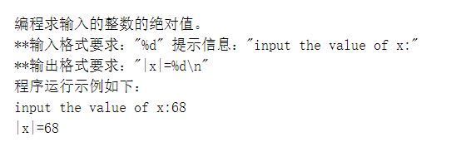

#include<stdio.h>

#include<math.h>

int main()

{

int n,m;

printf("input the value of x:");

scanf("%d",&n);

m = fabs(n);

printf("|x|=%d\n",m);

return 0;

}

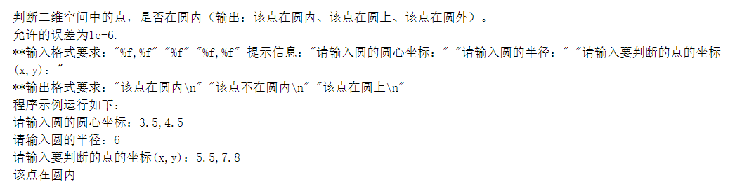

#include <stdio.h>

#include <math.h>

int main()

{

float a,b,r,x,y;

double m,n;

printf("请输入圆的圆心坐标：");

scanf("%f,%f",&a,&b);

printf("请输入圆的半径：");

scanf("%f",&r);

printf("请输入要判断的点的坐标(x,y)：");

scanf("%f,%f",&x,&y);

m=pow(x-a,2);

n=pow(y-b,2);

if (m+n<r\*r)

printf("该点在圆内\n");

else if (m+n>r\*r)

printf("该点不在圆内\n");

else if (m+n==r\*r)

printf("该点在圆上\n");

return 0;

}

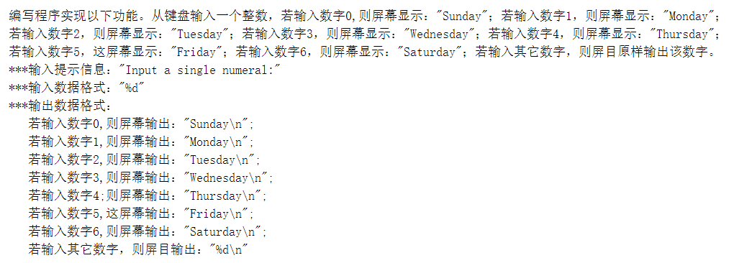

#include<stdio.h>

int main()

{

int n;

printf("Input a single numeral:");

scanf("%d",&n);

if(n==0)

printf("Sunday\n");

else if(n==1)

printf("Monday\n");

else if(n==2)

printf("Tuesday\n");

else if(n==3)

printf("Wednesday\n");

else if(n==4)

printf("Thursday\n");

else if(n==5)

printf("Friday\n");

else if(n==6)

printf("Saturday\n");

else printf("%d\n",n);

return 0;

}

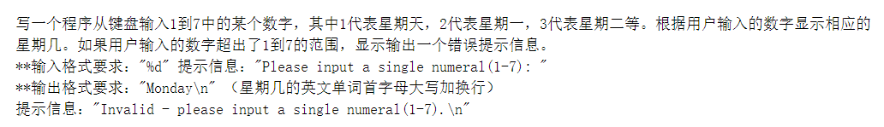

#include<stdio.h>

int main()

{

int n;

printf("Please input a single numeral(1-7): ");

scanf("%d",&n);

if(n==1)

printf("Sunday\n");

else if(n==2)

printf("Monday\n");

else if(n==3)

printf("Tuesday\n");

else if(n==4)

printf("Wednesday\n");

else if(n==5)

printf("Thursday\n");

else if(n==6)

printf("Friday\n");

else if(n==7)

printf("Saturday\n");

else printf("Invalid - please input a single numeral(1-7).\n");

return 0;

}

用if-else语句编程根据输入的百分制成绩score，转换成相应的五分制成绩grade后输出。已知转换标准为：

0-59 E

60-69 D

70-79 C

80-89 B

90-100 A

\*\*输入格式要求："%d" 提示信息："Please enter score:"

\*\*输出格式要求："Input error!\n" "%d——A\n"

程序运行示例1如下：

Please enter score:15

15——E

程序运行示例2如下：

Please enter score:85

85——B

#include<stdio.h>

main()

{

int score, mark;

printf("Please enter score:");

scanf("%d" , &score);

if (score < 0 || score > 100)

{

mark = -1;

}

else

{

mark = score / 10;

}

switch (mark)

{

case 10:

case 9:

printf("%d——A\n", score);

break;

case 8:

printf("%d——B\n", score);

break;

case 7:

printf("%d——C\n", score);

break;

case 6:

printf("%d——D\n", score);

break;

case 5:

case 4:

case 3:

case 2:

case 1:

case 0:

printf("%d——E\n", score);

break;

default:

printf("Input error!\n");

}

}

请编程计算居民应交水费，并提供各种测试数据。居民应交水费y（元）与月用水量x（吨）的函数关系式如下：

*y*=*f*(*x*)=⎧⎩⎨0,4*x*3,2.5*x*−10.5,*x*<00≤*x*≤15*x*>15

\*\*输入格式要求：信息提示："Enter x:" 输入格式："%lf"

\*\*输出格式要求："f(%.2f)=%.2f\n"

#include<stdio.h>

int main(void)

{

double x, y;

printf("Enter x:");

scanf("%lf", &x);

if (x < 0)

{

y = 0;

printf("f(%.2f)=%.2f\n", x, y);

}

else if (x >= 0 && x <= 15)

{

y = 4 \* x / 3.0;

printf("f(%.2f)=%.2f\n", x, y);

}

else

{

y = 2.5 \* x - 10.5;

printf("f(%.2f)=%.2f\n", x, y);

}

}

编程计算分段：

y= x x<1

y= 2x-1 1<=x<10

y= 3x-11 x>=10

从键盘输入一个单精度实数x，打印出y值。

\*\*输入提示信息格式要求为："Please input x:"；

\*\*输出格式要求为"y = %.2f\n"。

#include<stdio.h>

int main()

{

float x, y;

printf("Please input x:");

scanf("%f", &x);

if (x < 1)

{

y = x;

}

else if (x >= 10)

{

y = 3 \* x - 11;

}

else

{

y = 2 \* x - 1;

}

printf("y = %.2f\n", y);

return 0;

}

小明今年12岁，他母亲比他大24岁。编写一个程序计算小明的母亲在几年后比小明的年龄大一倍，那时他们两人的年龄各是多少？

\*\*输出格式要求："year=%d\n" "mingAge=%d\n" "motherAge=%d\n"

程序运行示例如下：

year=12

mingAge=24

motherAge=48

#include <stdio.h>

int main()

{

int a=12,b=12+24,i=0;

for (i=1; ;i++)

{

a++;

b++;

if (a\*2==b)

{

break;

}

}

printf("year=%d\n",i);

printf("mingAge=%d\n",a);

printf("motherAge=%d\n",b);

return 0;

}

编写一个程序完成输入一个整数，输出它的符号。

\*\*输入格式要求："%d" 提示信息："Enter n:"

\*\*输出格式要求："+\n" "-\n" "this number has no sign\n"

程序运行示例1如下：

Enter n:90

+

程序运行示例2如下：

Enter n:0

this number has no sign

#include <stdio.h>

int main()

{

int a;

printf("Enter n:");

scanf("%d", &a);

if (a == 0)

printf("this number has no sign\n");

else if (a < 0)

printf("-\n");

else

printf("+\n");

}

编程判断输入整数的正负性和奇偶性。

\*\*输入格式要求："%d" 提示信息："Input m:"

\*\*输出格式要求：

如果是负偶数，则输出"%d is a negative even\n"

如果是负奇数，则输出"%d is a negative odd\n"

如果是正偶数，则输出"%d is a positive even\n"

如果是正奇数，则输出"%d is a positive odd\n"

如果是0，则输出"%d is zero. It is an even\n"

程序运行示例1：

Input m:6↙

6 is a positive even

程序运行示例2：

Input m:0↙

0 is zero. It is an even

#include<stdio.h>

int main()

{

int a;

printf("Input m:");

scanf("%d", &a);

if (a % 2 == 0 && a < 0)

printf("%d is a negative even\n", a);

else if (a % 2 == 0 && a > 0)

printf("%d is a positive even\n", a);

else if (a % 2 != 0 && a > 0)

printf("%d is a positive odd\n", a);

else if (a % 2 != 0 && a < 0)

printf("%d is a negative odd\n", a);

else

printf("%d is zero. It is an even\n", a);

return 0;

}

求两个整数中的较大值。

\*\*输入格式要求："%d%d" 提示信息："input a and b="

\*\*输出格式要求："The max of a and b :%d\n"

程序运行示例如下：

input a and b=5 6

The max of a and b :6

#include<stdio.h>

int main()

{

int a,b;

printf("input a and b=");

scanf("%d%d",&a,&b);

if(a-b>0)

printf("The max of a and b :%d\n",a);

else

printf("The max of a and b :%d\n",b);

return 0;

}

从键盘任意输入一个年号，判断它是否是闰年。已知符合下列条件之一者是闰年：（1）能被4整除，但不能被100整除；（2）能被400整除。

输入提示信息："Input a year:"

输入格式："%d"

输出提示信息和格式：

"%d is a leap year!\n"

"%d is not a leap year!\n"

#include<stdio.h>

int main()

{

int a,b,c,d;

printf("Input a year:");

scanf("%d",&a);

b = a%4;

c = a%100;

d = a%400;

if((b==0&&c>0)||d==0)

{

printf("%d is a leap year!\n",a);

}

else

{

printf("%d is not a leap year!\n",a);

}

return 0;

}

编程求两个整数中的最大值。

\*\*输入格式要求："%d%d" 提示信息："input the value of x and y:"

\*\*输出格式要求："The max of %d and %d is %d\n"

程序示例运行如下：

input the value of x and y:3 4

The max of 3 and 4 is 4

#include<stdio.h>

int main()

{

    int a,b;

    printf("input the value of x and y:");

    scanf("%d%d",&a,&b);

    if(a-b>0)

    printf("The max of %d and %d  is %d\n",a,b,a);

    else

    printf("The max of %d and %d  is %d\n",a,b,b);

    return 0;

}

判断二维空间中的点，是否在圆内（输出：该点在圆内、该点在圆上、该点在圆外）。

允许的误差为1e-6.

\*\*输入格式要求："%f,%f" "%f" "%f,%f" 提示信息："请输入圆的圆心坐标：" "请输入圆的半径：" "请输入要判断的点的坐标(x,y)："

\*\*输出格式要求："该点在圆内\n" "该点不在圆内\n" "该点在圆上\n"

程序示例运行如下：

请输入圆的圆心坐标：3.5,4.5

请输入圆的半径：6

请输入要判断的点的坐标(x,y)：5.5,7.8

该点在圆内

#include <stdio.h>

#include <math.h>

int main()

{

float a,b,r,x,y;

double m,n;

printf("请输入圆的圆心坐标：");

scanf("%f,%f",&a,&b);

printf("请输入圆的半径：");

scanf("%f",&r);

printf("请输入要判断的点的坐标(x,y)：");

scanf("%f,%f",&x,&y);

m=pow(x-a,2);

n=pow(y-b,2);

if (m+n<r\*r)

printf("该点在圆内\n");

else if (m+n>r\*r)

printf("该点不在圆内\n");

else if (m+n==r\*r)

printf("该点在圆上\n");

return 0;

}

编程求输入的整数的绝对值。

\*\*输入格式要求："%d" 提示信息："input the value of x:"

\*\*输出格式要求："|x|=%d\n"

程序运行示例如下：

input the value of x:68

|x|=68

#include<stdio.h>

int main()

{

int a;

printf("input the value of x:");

scanf("%d",&a);

if(a>0)

printf("|x|=%d\n",a);

else

printf("|x|=%d\n",-1\*a);

return 0;

}